HOW TO CREATE NETWORK SHARE FOLDER VIA SAMBA

Network share resource (folder): in computing, a shared resource, or network share, is a computer resource made available from one host to other hosts on a computer network. It is a device or piece of information on a computer that can be remotely accessed from another computer transparently as if it were a resource in the local machine.

Samba: samba is the standard windows interoperability suite of programs for linux and unix. Samba is Free Software.

INSTALLATION AND CONFIGURATION

- Setup and Install Ubuntu Linux VM or Container
- Update Linus Os: sudo apt update
- Installing Samba on Linux OS: sudo apt install samba -y
- create folders that you want to share on the network: mkdir /dir/where you want to create the folder e.g mkdir /var/test
- give permission to the shared folder: e.g chmod 777 /var/test ( 777 read and write permission)
- edit samba configuration file: nano /etc/samba/smb.conf
- add shared folder configuration to samba configuration file, scroll to the last line of the config file and add the following
[share folder1] (change this to your preferred name)
comment = Share1 (change this to your preferred name)
path = /var/test (change this to the path folder that you created)
browseable = yes
read only = no
guest ok = yes

- save the configuration file (ctrl+o)
- restart samba or restart the linux Os

// to check the status of service: sudo service smbd status

// to start the service: sudo service smbd start

// to stop the service completely: sudo service smbd stop

// to restart samba services: sudo service smbd restart

- access the shared folder on windows system on the same network with your samba share: \\ip address of your linux os [e.g \\10.10.1.100]: if your configuration is correct you should see something similar.

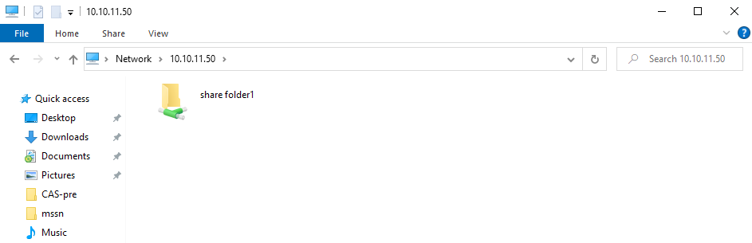
- open network share folder: right click and open
- create sample folder
- create sample file

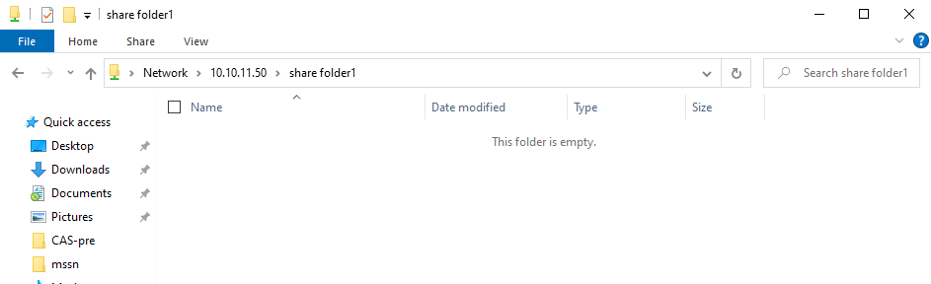

ADDING SECURITY TO SHARED FOLDER

- add a user that you want to give right on the shared folder: sudo useradd test --shell /bin/false (I use test as the username)
- set password for the user: smbpasswd -a test
- change ownership of the shared folder: sudo chown test /var/test
- edit samba configuration file to include permitted user: nano /etc/samba/smb.conf

[share folder1]
comment = Share1
path = /var/test
browseable = yes
read only = no
guest ok = yes
force user = test
force group = test

- save the configuration file (ctrl+o)
- restart samba or restart Linux os
- access shared folder: you will be ask to supply login detail
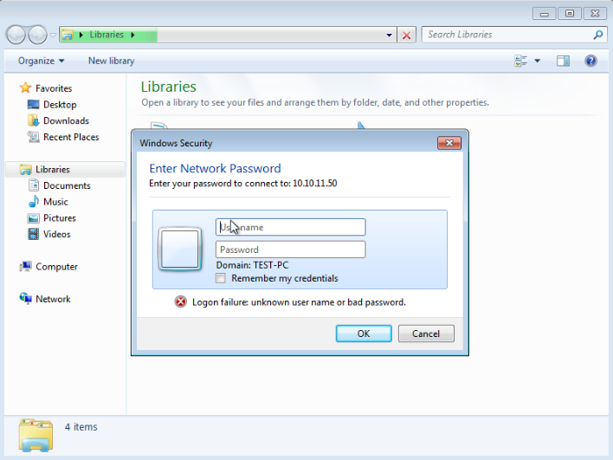

- After supplying correct login details
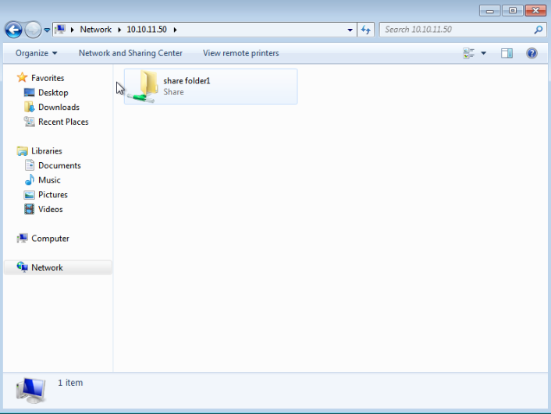

CREATING READ-ONLY SHARED FOLDER PERMISSION

- edit samba configuration file to include read-only configuration: nano /etc/samba/smb.conf
[share readonly]
comment = Share1
path = /var/test
browseable = yes
read only = yes
guest ok = yes

- save the configuration file (ctrl+o)
- restart samba or restart Linux os
- access shared folder: you will see a shared folder linking to the same folder but with read only permission (user can not delete)
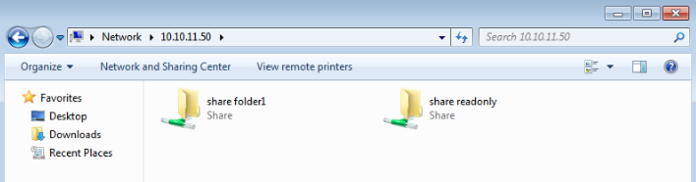
- try to delete a file or folder
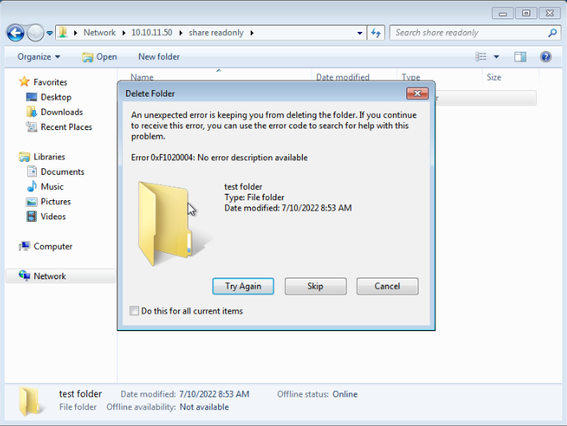

- Real life and use case will be discuss in class

